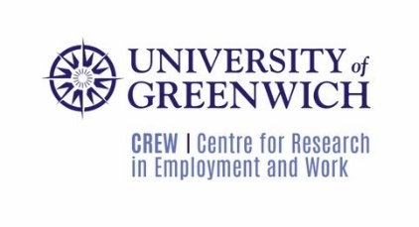

Workers in health and social care during Covid-19
We are conducting research exploring the experiences of workers in health and social care during Covid-19. We are independent researchers from the Centre for Research on Employment and Work (CREW) at the University of Greenwich. The research is funded by the Equality and Human Rights Commission (EHRC).

This research project is being commissioned by the EHRC to support a statutory inquiry under Section 16 and Schedule 2 of the Equality Act 2006. The primary focus for the inquiry is the health and adult social care sectors across Britain because of the high rates of infection and death from Covid-19 in these sectors, as well as the social care sector. It will aim to develop clear, evidence-based recommendations for action to tackle entrenched racial inequalities that have left ethnic minorities at the lowest paid and therefore most vulnerable when the pandemic arrived. The recommendations will provide learning for other sectors to ensure workers are valued and treated fairly.
The inquiry’s terms of references are available at:
https://www.equalityhumanrights.com/en/inquiries-and-investigations/inquiry-racialinequality-health-and-social-care-workplaces

To help us with our research, we are looking for home care and residential care workers, primarily from the Black and Minority Ethnic (BAME) community, to participate in interviews and focus groups.

All research participants will remain anonymous and we will not name your employer at any stage of the research and in any report that comes out of the research. Each interview will last about 30-45 minutes. Focus groups will involve other workers in health and social care, who may be from your area, and should last around one hour. We will ask you about your experiences at work during the Covid-19 crisis and how they have impacted on your wider experiences over the last year. Interviews and focus groups will be on-line (via Zoom) and at a time convenient to you. We will offer a £25 gift card to each participant to acknowledge your time in the current situation.

Please be assured that you can pull out of the interview or focus group at any time, without having to give a reason. You can withdraw your contribution to the project at any time up to two months after the interview takes place.

If you are interested in taking part in either an interview or a focus group, please email Sian Moore at the University of Greenwich at s.moore@greenwich.ac.uk.

